3GPP TSG RAN WG1 #125 R1- 2603763
Dalian, China, May. 18th ~ 22nd, 2026

Source: Tejas Networks
Title: Study on Target Echoes delayed beyond CP length
Agenda Item: 10.8.3 – ISAC – Waveform & Frame Structure
Document for: Discussion & Decision
- Introduction
According to the chair notes RAN1#124bis Malta, MT Apr 13th -17th, section 10.8.3 - Waveform and frame structure, companies to investigate the use of extended CP and provide a study on echoes beyond the cyclic prefix.

Chair notes, RAN1#124bis, Malta, MT Apr 13th – 17th, section 10.8.3 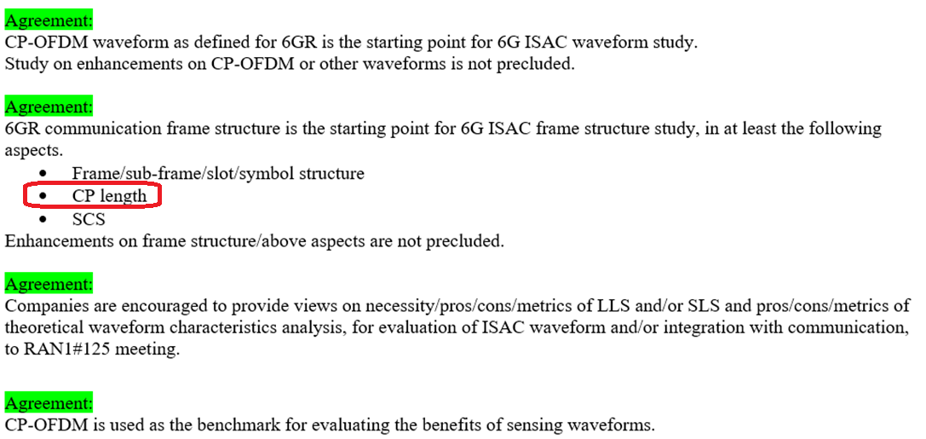
Considering a 3GPP configuration with BW 100MHz and subcarrier spacing 30kHz,
- The symbol duration is given by $\frac{NFFT}{Fs}=\frac{4096}{122.88MHz}$= 33.33μs (numerology = 1)
- CP length is of duration $\frac{CP samples}{Fs}=\frac{288}{122.88MHz}$ = 2.34375μs. (numerology = 1)
For monostatic sensing, this implies that echoes from targets located beyond 351.56 meters would overlap with subsequent symbols, resulting in inter‑symbol interference.
Observation 1: For numerology 1, echo delays from targets located beyond 351.6 m exceed the cyclic prefix length
- Tx-Rx Timing Offset at base-station
It is important to note that UEs apply a timing advance so that their uplink transmissions arrive at the base station in a synchronized manner, ensuring proper alignment across all UEs. The UE shall start $T_{TA}=\left(N_{TA}+N_{TA,offset}\right)∙T_{c}$ before the start of the corresponding downlink frame at the UE
It says the timing advance also includes a “Timing Offset”
$$t_{offset}=N_{TA_offset}∙T_{c}$$
where $T_{c}=\frac{1}{∆f_{max}∙N_{f}}=\frac{1}{480kHz∙4096}=0.5086ns$
And as per [2] table 7.1.2-2, this $N_{TA_offset}$ is 25600 for FR1, when coexistence with LTE is not needed.
Hence $t_{offset}=25600∙0.5086ns=13.02s$
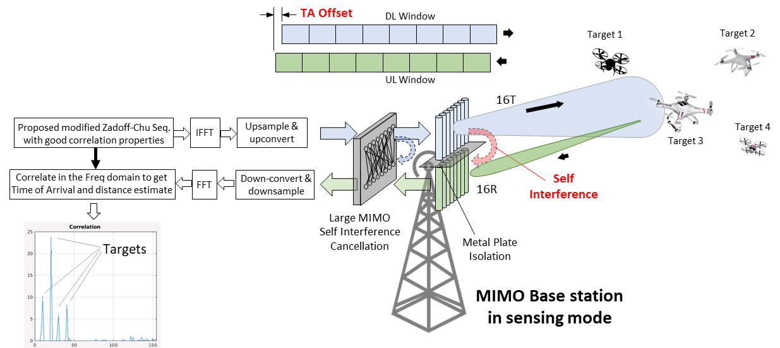
Figure 1: Uplink/downlink TA Offset
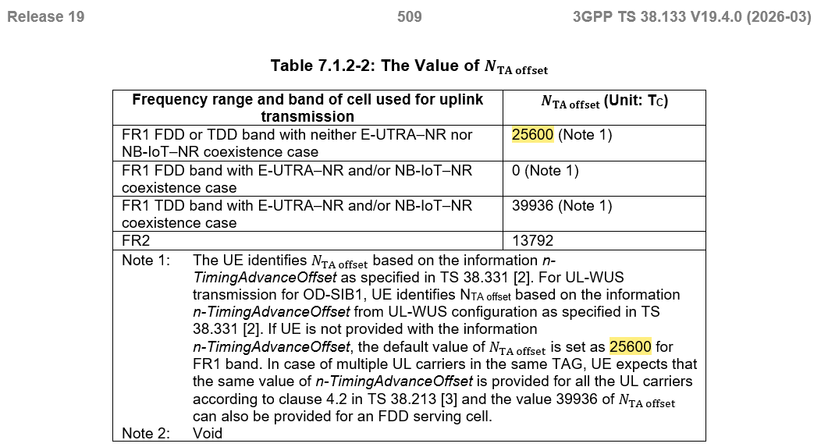
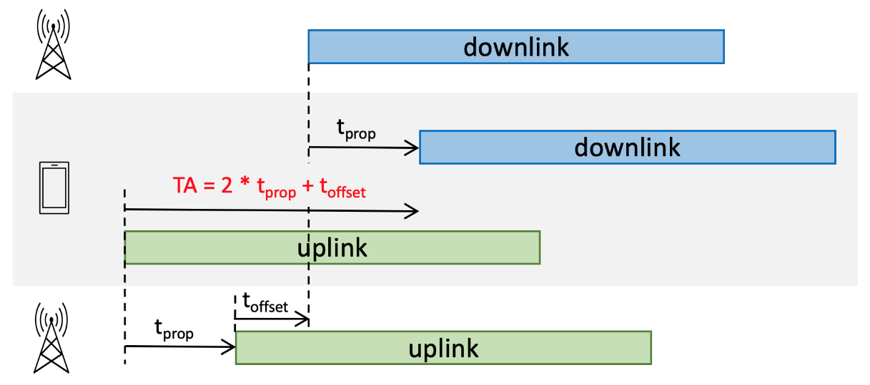
Figure 2: Uplink/downlink timing from BS/UE perspective
The purpose of this $t_{offset}$ is for a TDD base station to activate its transmitter after an uplink frame.
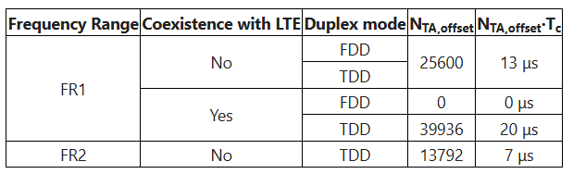
Observation 2: Looking ahead, an appropriate TA offset may need to be defined in RAN4 for FR3, with ISAC requirements taken into account.
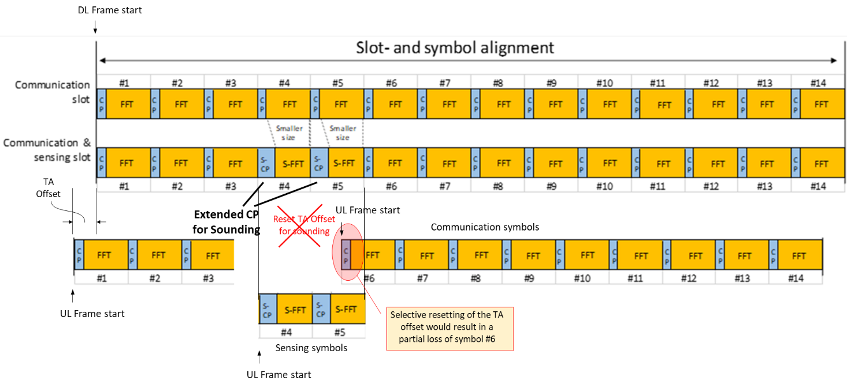
Figure 3: TA offset cannot be reset selectively
This timing offset cannot be reset selectively for sensing symbols, as is illustrated in Figure 3. This is because UL frames would be lost moving from symbol#5 to symbol#6.
Observation 3: In FR1, a target echo that should register at zero delay instead appears with a 13‑μs delay because of the transmit‑receive timing advance (TA_offset) applied at the base station.
Proposal 1: Instead of resetting the TA‑offset specifically for sounding symbols, the more effective approach is to adjust the measured delay afterward during post‑processing, even if the delay exceeds the cyclic prefix.
- Effect of Comb size on CP length and unambiguous range
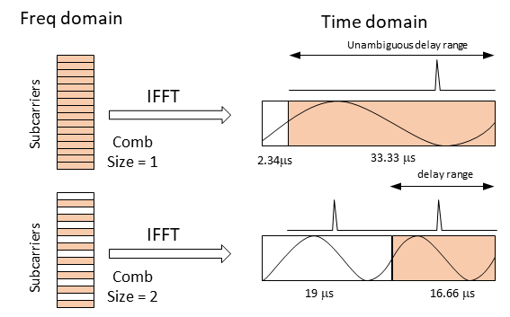
Figure 4: Effect of comb size for sounding
  - Cyclic Prefix
When comb size 2 is used, and the alternate subcarrier remains unused, the effect is equivalent to up‑sampling in the frequency domain. This translates into symbol repetition in the time domain, which in turn leads to an effective increase in the cyclic prefix (CP) length. As illustrated in Figure 4, the CP length extends from 2.34 µs to 19 µs.
  - Correlation gain
When the comb size increases from 1 to 2, the correlation gain drops by about 3 dB, though this reduction is generally considered acceptable.
  - Unambiguous Range
The unambiguous range of a sensing system is determined by the length of its correlation window. Since using comb size 2 halves the correlation window (compared to that of a comb size 1), the unambiguous range is correspondingly reduced.
By contrast, choosing comb size 1 provides a larger correlation window, thereby supporting a greater range. To achieve the higher sample rate needed for improved range resolution, numerology 1 is selected, which supports a sample rate of 122.88 MHz (SCS = 30kHz, BW ≥ 60 MHz, NFFT = 4096)
Thus, the correlation window $=\frac{N_{FFT}}{F_{s}}=\frac{4096}{122.88MHz}=33.33μs$
With a comb size = 2, the signals are effectively up‑sampled in the frequency domain, which results in repetition in the time domain. This produces two correlation peaks within a single symbol duration and reduces the correlation window to 16.66 µs
Observation 4: Using comb sizes > 1 reduces correlation gain and shortens the correlation window, which in turn restricts the maximum unambiguous range that can be observed. If the other subcarriers are unutilized, the CP length increases
Proposal 2: Comb Size 1 Maximizes Unambiguous Range.
- Correlation with partial overlaps
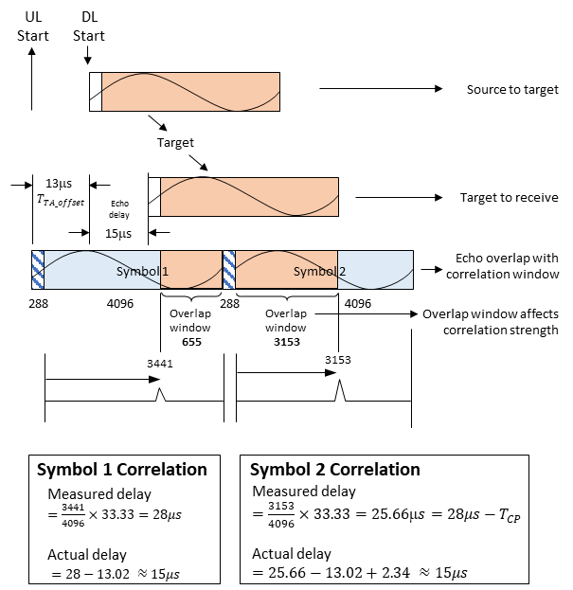
Figure 5: Correlation with partial overlaps over subsequent symbols
A delayed signal may partially overlap with the correlation window, and if the same sensing symbol is repeated, the overlap can extend across two consecutive symbols, resulting in two distinct correlation outcomes.
There are two things to be noted here
  - Second Peak Shifts by CP Length
As shown in Figure 5, the second correlation peak position appears one cyclic‑prefix length earlier than the first, within their respective symbols.
  - Symbol overlap defines Correlation strength
The second symbol’s correlation peak can be stronger if a larger portion of the symbol falls within the second correlation window, as illustrated in Figure 5.
Observation 5: When a sensing symbol is repeated, delayed echoes can partially overlap with the correlation window, causing correlation across two consecutive symbols and producing two distinct correlation results
Observation 6: For consecutive symbol correlation, the second correlation peak advances by CP length
Observation 7: Correlation strength in consecutive symbols depends on the overlap window.
Observation 8: Due to the timing‑advance (TA) offset, echoes inevitably extend beyond the cyclic prefix length, making it necessary to rely on partial correlation for detection
- Same Symbol Repeated Across Sweeps
As noted in [3], overlapping beams sweep across the sector. Repeating the same symbol helps ease the AoA estimation and also detects a partial correlation in the 2nd pass
  - 3GPP frame structure supporting beam-sweeping and slow time
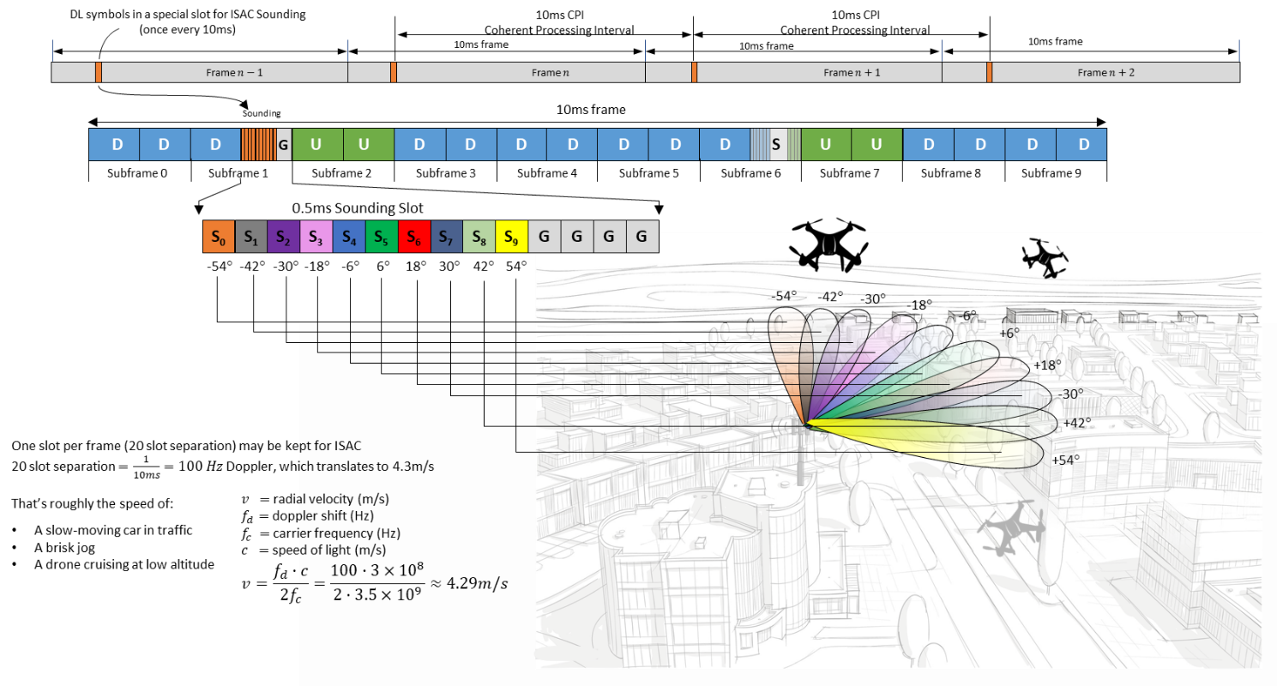
Figure 6: Symbol Repetition aids 2nd‑Pass Correlation & AoA
Proposal 3: Repeating symbols not only enable partial correlation but also support beam sweeping and enhance angle‑of‑arrival (AoA) estimation.
- Conclusion
In this contribution, we report the following methods we considered for associating detected objects with true targets
Observation 1: For numerology 1, echo delays from targets located beyond 351.6 m exceed the cyclic prefix length
Observation 2: Looking ahead, an appropriate TA offset may need to be defined in RAN4 for FR3, with ISAC requirements taken into account.
Observation 3: In FR1, a target echo that should register at zero delay instead appears with a 13‑μs delay because of the transmit‑receive timing advance (TA_offset) applied at the base station.
Proposal 1: Instead of resetting the TA‑offset specifically for sounding symbols, the more effective approach is to adjust the measured delay afterward during post‑processing, even if the delay exceeds the cyclic prefix.
Observation 4: Using comb sizes > 1 reduces correlation gain and shortens the correlation window, which in turn restricts the maximum unambiguous range that can be observed. If the other subcarriers are unutilized, the CP length increases
Proposal 2: Comb Size 1 Maximizes Unambiguous Range.
Observation 5: When a sensing symbol is repeated, delayed echoes can partially overlap with the correlation window, causing correlation across two consecutive symbols and producing two distinct correlation results
Observation 6: For consecutive symbol correlation, the second correlation peak advances by CP length
Observation 7: Correlation strength in consecutive symbols depends on the overlap window.
Observation 8: Due to the timing‑advance (TA) offset, echoes inevitably extend beyond the cyclic prefix length, making it necessary to rely on partial correlation for detection
Proposal 3: Repeating symbols not only enable partial correlation but also support beam sweeping and enhance angle‑of‑arrival (AoA) estimation.
- References
[1] Chair Notes, RAN1#124bis, 3GPP TSG RAN WG1 #124bis, St. Julian’s, Malta, April 13th ~ 17th, 2026.
[2] 3GPP TS 38.133 v19.4.0 (2026-03)
[3] R1-2602084 Frame Structure for ISAC with Beam Sweeping_10.8.3_TejasNetworksLimited

